Installing Python Using Anaconda

- Anaconda is the company in charge of Conda, a package and environment management system that runs on Windows, macOS, and Linux.

- In this class, we will use Conda to install Python and manage the packages we will use throughout the semester (if you prefer any other management system, feel free to use it, but all the class material will use Conda)

- Conda quickly installs, runs, and updates packages and their dependencies.

- Conda easily creates, saves, loads, and switches between environments on your local computer (we will cover what environments are and how to use them during this class).

- Conda was created for Python programs, but it can package and distribute software for any language (think for example R or Java).

Installation process
- Go to the Anaconda Website and select the Windows/MacOS button.
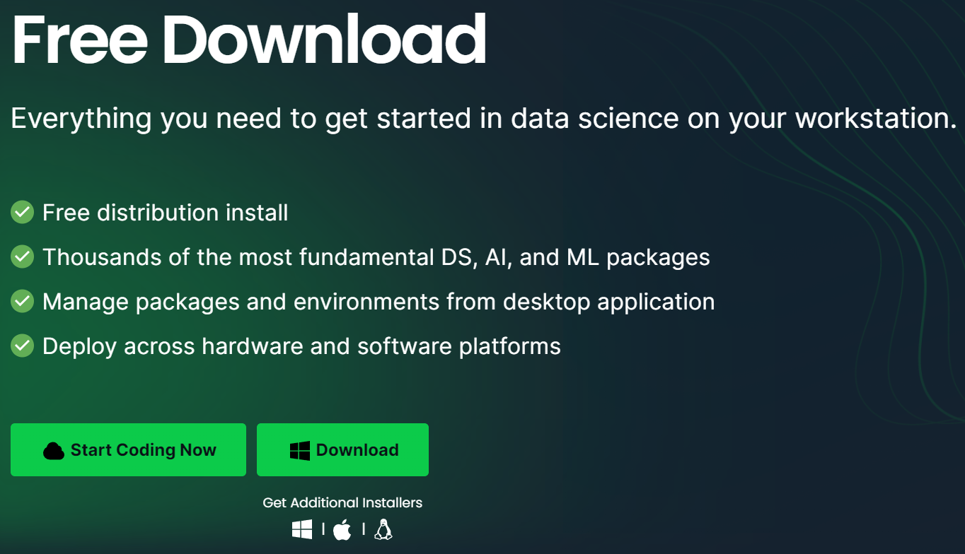
- Follow the installation process prompted by the executer you downloaded in the previous step.

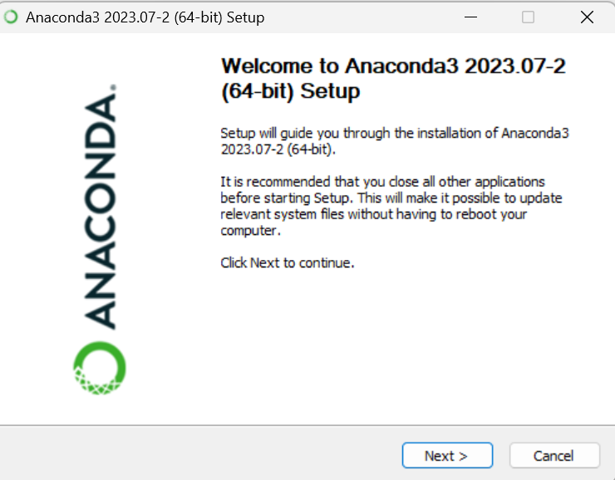
I recommend you use all the default options in the installation process.

- Check the installation was successful. Anaconda installs a graphical user interphase (application) called Anaconda Navigator. If your installation was successful, you should have access to Anaconda Navigator, which should look similar to the following picture.
